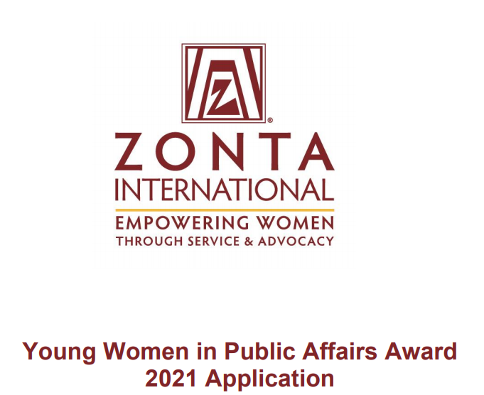

Who is Eligible?
Women, aged 16-19 on 1st April each year, living in a Zonta district/region, or who are citizens of a Zonta country, who demonstrate evidence of the following, are eligible to apply.
❑ Active commitment to volunteerism.
❑ Experience in local government, student government, or workplace leadership (paid or unpaid).
❑ Volunteer leadership achievements.
❑ Knowledge of Zonta International and its programs.
❑ Support for Zonta International’s mission of empowering women worldwide through service and advocacy.

Send you application to:
Zontaclub Rotterdam - Bestuuur.zonta-rotterdam@gmail.com, e/o Janneke Metsaars
Deadline for sending in an application form: 8 March 2021
Make sure to add at least 1 confidential recommendation letter with signature to support your application.

applicant’s Personal data:

First name |  | Last name
Address |  | Zip code
City |  | Tel number
Email address |  | Date of birth
School |  | Enrolled since (mm-yyyy)

PERSONAL GOALS
Please describe in short your anticipated course of study and current career interests, including whether and how you plan to be active in volunteer or community organizations. (150 words) Please provide the word count at the end of your answer.

Please answer all questions below, noting the word limit for each. In evaluating applications, all questions are rated in equal value.
Question 1. Activities related to your school/workplace. Please include (a) your leadership experience, and (b) what you find most rewarding or valuable about your participation in these activities (no more than 200 words). Please provide the word count at the end of your answer.

2. Activities not related to your school/workplace. Describe the activities in which you participate as a volunteer that benefit other causes and any leadership roles you have had in those activities. Please include with these activities a description of any experience in local government, international, or other projects (no more than 200 words). Please provide the word count at the end of your answer. 6

3. International Awareness. Describe the activities you participate in which increase your experience, knowledge and understanding of other countries and their different customs (no more than 150 words). Please provide the word count at the end of your answer.

4. Status of Women in your Country Describe your experience in empowering women through service and advocacy. Are there any issues which hinder women’s empowerment in your country? Describe your ideas for resolving them (no more than 300 words). Please provide the word count at the end of your answer.

